### IP Fragmentation Example 1 Answer

#### **An IP Packet of 8200 bytes (total length) is to be transmitted over a link with a frame size MTU of 512 bytes:**

1. **How many bytes of data are to be transmitted?** A: 8180 bytes   
   - The total packet length given is 8200 which includes 20 bytes of IP header  
   - We then have 8200 - 20 = **8180 bytes** of data to be transmitted.
2. **How many bytes of data can be carried in each fragment?**A: 488 bytes  
   - The total length of the fragment, including 20 bytes of header, must be 512 bytes or less.   
   - We can then carry a maximum of 512 - 20 = 492 bytes of data in a fragment.  
   - Now, because the offset value must be a multiple of 8, the amount of data bytes must be a multiple of 8  
   - 492 is NOT a multiple of 8, so we have to go with the closest lower multiple of 8, i.e **488 bytes**
3. **How many IP fragments must be sent?**A: 17  
   - We must transmit 8180 bytes of data, and can carry 488 (or less) bytes in a fragment  
   - 8180/488 = 16.76   
   - We must send 16 fragments carrying 488 bytes each, plust a last one carrying the remaining  
   - Then, we must send **17 fragments** in total.
4. **What is the offset value for the third IP fragment?**A: 122  
   - The offset represents the relative position of the first byte in the fragment, expressed in multiples of 8  
   - The first fragment carries bytes 0 to 487. The offset in the first fragment is 0,  
   - The second fragment carries bytes 488 to 975. The offset in the second fragment is 488/8 = 61  
   - The third fragment carries bytes 976 to 146. The offset in the third fragment is 976/8 = **122**  
     
   Another way to look at it is:  
   - The offset increment is the amount of data bytes carried divided by 8, i.e 488/8 = 61  
   - The offset in the first fragment is always 0  
   - The offset in the second fragment is 0+61 = 61  
   - The offset in the third fragment is 61+61 = **122**

### IP Fragmentation Example 2

#### **An IP Packet carrying 40000 data bytes is to be transmitted over a link with a frame size MTU of 1480 bytes:**

1. **How many bytes of data are to be transmitted?**A: 40000
2. **How many bytes of data can be carried in each fragment?**A: 1456 bytes  
   - We must consider that each fragment will have 20 bytes of header  
   - With an MTU of 1480, an IP packet can carry a max. of 1460 bytes of data  
   - Because the offset must be a multiple of 8, the amount of data bytes carried must also be a multiple of 8  
   - 1460 is NOT a multiple of 8, so we find the closest one  
   - Then, each fragment can carry **1456** bytes of data
3. **How many IP fragments must be sent?**A: 28  
   - 40000/1456 = 27.48  
   - We must sent 27 fragments with 1456 bytes of data, plus 1 with the reminder. i.e. **28 fragments**
4. **What is the offset value for the 4th IP fragment?**A: 546  
   - The fragment data size is 1456, then the offset increment is 1456/8 = 182  
   - The Fragment 1 offset is 0, Fragment 2 offset is 182, Fragment 3 offset is 364  
   - Fragment 4 offset is **546**
5. **A fragment is lost in the way. Will the IP layer retransmit the fragment?**A: NO

IP is best effort, it does not keep track of packet to ensure they reach destination. Retransmissions are handled by the upper layers.

### IP Fragmentation Example 3

#### **An IP Packet with a total size of 12000 bytes is to be transmitted over a link with a frame size MTU of 1500  bytes:**

1. **How many bytes of data are to be transmitted?**
2. **How many bytes of data can be carried in each fragment?**
3. **How many IP fragments must be sent?**
4. **What is the offset increment?**

VLSM Scenario 1

You must optimally subnet the allocated major network, and answer the following questions:

1. How many subnets are needed in total? 6
2. Calculate the subnet address and the subnet mask for each network

Asgard: 212.125.8.0/26  
New York: 212.125.8.64/27  
New Jersey: 212.125.8.96/27  
Vormir: 212.125.8.128/29  
Link1: 212.125.8.136/30  
Link2: 212.125.8.140/30

1. What is the broadcast address for the Asgard network? 212.125.8.63
2. What is the first usable IP for the the New Jersey network? 212.125.8.97
3. What is the last usable IP address in the New York network? 212.125.8.94

VLSM Scenario 2

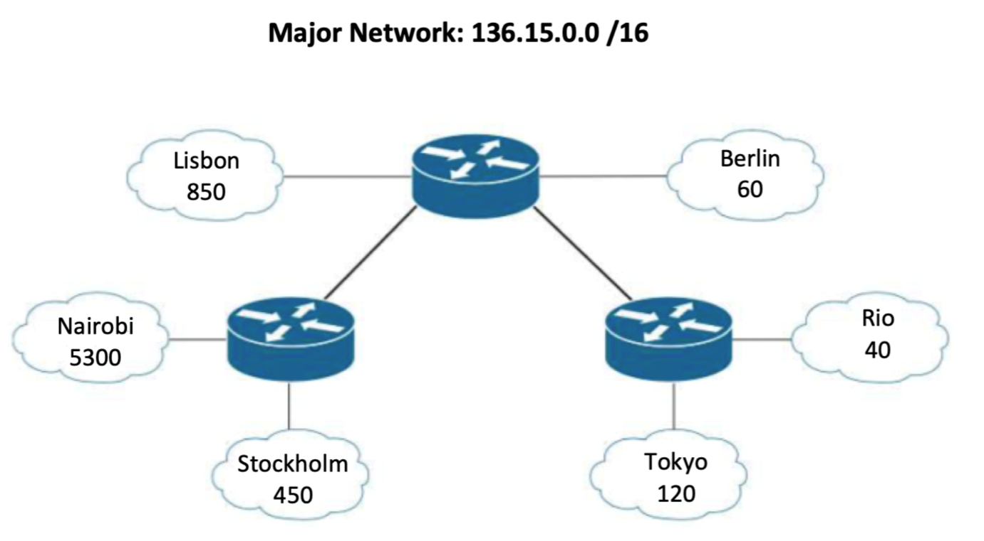

You must optimally subnet the allocated major network, and answer the following questions:

1. How many subnets are needed in total? 8 Subnets
2. Calculate the subnet address and the subnet mask for each network

Nairobi: 136.15.0.0/19

Lisbon: 136.15.32.0/22

Stockholm: 136.15.36.0/23

Tokyo: 136.15.38.0/25

Berlin: 136.15.38.128/26

Rio: 136.15.38.192/26

Link 01: 136.15.39.0/30

Link 02: 136.15.39.4/30

3. What is the broadcast address for the Tokyo network? 136.15.38.127/25

4. What is the first usable IP for the the Rio network? 136.15.38.193/26

5. What is the last usable IP address in the Lisbon network? 136.15.35.254/22

6. What is the unused range? 136.15.39.8/30 to 136.15.39.255/30

VLSM Scenario 3

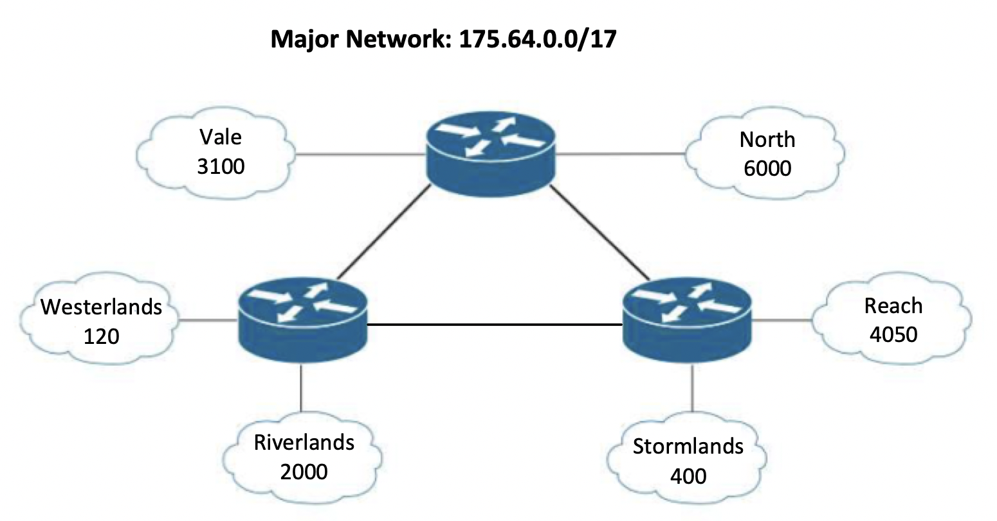

1. How many subnets are needed in total? 9
2. Calculate the subnet address and the subnet mask for each network  
   North - 175.64.0.0/19  
   Reach - 175.64.32.0/20  
   Vale - 175.64.48.0/20  
   Riverlands - 175.64.64.0/21  
   Stormlands - 175.64.72.0/23  
   Westerlands - 175.64.74.0/25  
   Link1 - 175.64.74.128/30  
   Link2 - 175.64.74.132/30  
   Link3 - 175.64.74.136/30
3. What is the broadcast address for the Riverlands network? 175.64.71.255
4. What is the first usable IP for the the Westerlands network? 175.64.74.1
5. What is the last usable IP address in the North network? 175.64.31.254
6. What is the unused range? 175.64.74.140 - 175.64.127.255

VLSM Scenario 4

1. How many subnets are needed in total? 9
2. Calculate the subnet address and the subnet mask for each network  
   ATC 136.186.224.0/21  
   EN 136.186.232.0/21  
   AD 136.186.240.0/22  
   LB 136.186.244.0/23  
   BA 136.186.246.0/23  
   UN 136.186.248.0/25  
   Link1 136.186.248.128/30  
   Link2 136.186.248.132/30  
   Link3 136.186.248.136/30
3. What is the broadcast address for the ATC network? 136.186.231.255
4. What is the first usable IP for the the LB network? 136.186.244.1
5. What is the last usable IP address in the UN network? 136.186.248.126
6. What is the unused range? 136.186.248.140 – 136.186.255.255

VLSM Scenario 5

1. How many subnets are needed in total?  9
2. Calculate the subnet address and the subnet mask for each network
   * Exhibition - 45.90.64.0/21
   * Williams - 45.90.72.0/22
   * Bourke - 45.90.76.0/23
   * Flinders - 45.90.78.0/24
   * Lonsdale - 45.90.79.0/26
   * Collins - 45.90.79.64/28
   * Link 1 - 45.90.79.80/30
   * Link 2 - 45.90.79.84/30
   * Link 3 - 45.90.79.88/30
3. What is the broadcast address for the Lonsdale network? 45.90.79.63
4. What is the first usable IP for the the Collins network? 45.90.79.65
5. What is the last usable IP address in the Williams network? 45.90.75.254
6. What is the unused range? 45.90.79.92 - 45.90.127.255

VLSM Scenario 6

1. How many subnets are needed in total? There are 9 subnets
2. Calculate the subnet address and the subnet mask for each network
   * Emporium: 103.5.128.0/19
   * Doncaster: 103.5.160.0/20
   * Chadstone: 103.5.176.0/22
   * Eastland: 103.5.180.0/23
   * Jam Factory: 103.5.182.0/27
   * Melbourne Central: 103.5.182.32/27
   * Link 1: 103.5.182.64/30
   * Link 2: 103.5.182.68/30
   * Link 3: 103.5.182.72/30
3. What is the broadcast address for the Chadstone network? 103.5.179.255
4. What is the first usable IP for the Doncaster network? 103.5.160.1
5. What is the last usable IP address in the Emporium network? 103.5.159.254
6. What is the unused range? 103.5.182.76 - 103.5.255.255

VLSM Scenario 7

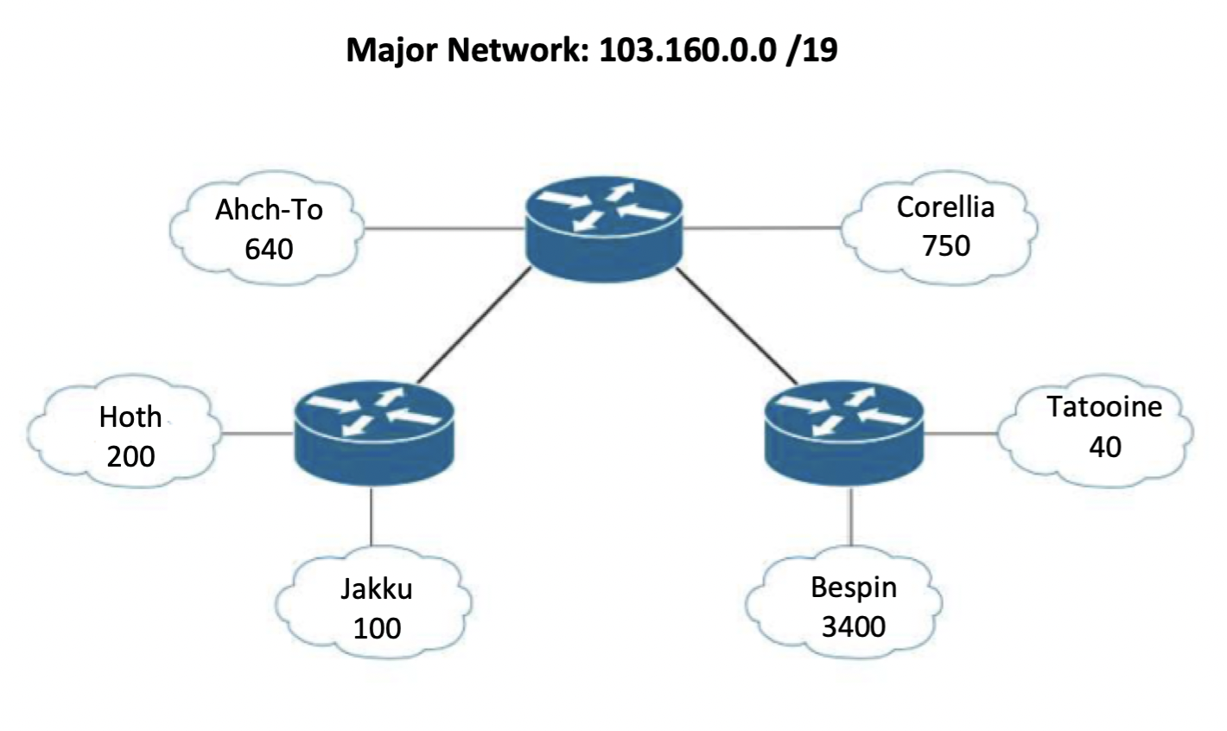

You must optimally subnet the allocated major network, and answer the following questions:

1. How many subnets are needed in total? 8
2. Calculate the subnet address and the subnet mask for each network  
   Bespin: 103.160.0.0/20  
   Corellia: 103.160.16.0/22  
   Ahch-To: 103.160.20.0/22  
   Hoth: 103.160.24.0/24  
   Jakku: 103.160.25.0/25  
   Tatooine: 103.160.25.128/26  
   Link 1: 103.160.25.192/30  
   Link 2: 103.160.25.196/30
3. What is the broadcast address for the Tatooine network? 103.160.25.191
4. What is the first usable IP for the the Jakku network? 103.160.25.1
5. What is the last usable IP address in the Hoth network?103.160.24.254
6. What is the unused range? 103.160.25.200 - 103.160.31.255

VLSM Scenario 8

You must optimally subnet the allocated major network, and answer the following questions:

1. How many subnets are needed in total?
2. Calculate the subnet address and the subnet mask for each network
3. What is the broadcast address for the Caracas network?
4. What is the first usable IP for the the Maracay network?
5. What is the last usable IP address in the Merida network?
6. What is the unused range?